**A**

**PROJECT REPORT**

**ON**

**LIC AGENT**

**SUBMITTED BY**

Mr. Rachchh Darshan

Mr. Pobaru Darshan

**ACADEMIC YEAR 2021-22**

**T.Y B.C.A. SEM - 5**

**UNDER THE GUIDANCE OF**

Mr. Khushal Rajani

**SMT. C.Z.M GOSRANI B.C.A. COLLEGE**

**JAMNAGAR**

**SUBMITTED TO**



**SAURASHTRA UNIVERSITY**

**RAJKOT**

**A**

**PROJECT REPORT**

**ON**

**LIC AGENT**

**SUBMITTED BY**

Mr. Rachchh Darshan

Mr. Pobaru Darshan

**ACADEMIC YEAR 2021-22**

**T.Y B.C.A. SEM - 5**

**UNDER THE GUIDANCE OF**

Mr. Khusal Rajani

**SMT. C.Z.M GOSRANI B.C.A. COLLEGE**

**JAMNAGAR**

**SUBMITTED TO**



**SAURASHTRA UNIVERSITY**

**RAJKOT**

# **ABSTRACT**

LIC agent is a Web application for all LIC agents. With the help of this application, the LIC agent can save all the information of its customers. And the LIC agent can also know how much commission he gets. In addition, each policy can get information about it. and the agent can also calculate how much the customer will benefit from which policy.

Even nowadays many LIC agents are seen using different types of materials for commission and for their clients to understand the policy. And it is a bit difficult to explain all the policy information in one paper.

All these limitations are removed by the LIC agent application. With the help of this web application, the LIC agent can save the details of his client in any place on his mobile and also find out the commission he gets himself. You will not need different materials to explain about policy. It can easily explain about each policy with the help of this LIC agent application in mobile.

# **ACKNOWLEDGEMENT**

We feel great pleasure in submitting this project report as a part of our B.C.A. Semester 5 curriculum. A practical study plays an important role.

For the successful completion of our project, we would especially like to thank our parents for their support and unconditional help. We would also like to thank our Project Guide Khushal Rajani for their constant support and help in implementation of this project.

We are also thankful to our Principal Ma'am, Ms. Hetal G. Savla for all the facilities they provided throughout our semester and for encouraging us to take up this activity.

Lastly, we would also like to thank the faculties and staff members of Smt. C.Z.M. Gosrani B.C.A. College, Jamnagar.

# **PROJECT PROFILE**

|  |  |  |
| --- | --- | --- |
| STUDENT INFORMATION | | |
| Name  Mr. Pobaru Darshan  Mr. Rachchh Darshan | **Enrollment Numbers**  00320320879  00320320880 | |
| PROJECT DETAILS | | |
| Project Title | LIC agent | |
| Duration | 4 Months | |
| Name of Project | LIC agent | |
| Platform | PHP  MySQL | |
| Team Size | 2 | |
| GUIDE INFORMATION | | |
| Name of Guide | | Mr. Khushal Rajani |

# **INDEX**

|  |  |  |
| --- | --- | --- |
| Chapter | Title | Page No. |
| 1 | **Overview of the accepted SDLC Model** |  |
| 2 | **Requirement Gathering and Analysis** |  |
|  | 2.1 Organization Details |  |
| 2.2 Meetings |  |
| 2.3 Type of Project |  |
| 2.4 Method of collecting requirements |  |
| 3 | **System Requirement Specification** |  |
|  | 3.1 Introduction |  |
| 3.1.1 Purpose |  |
| 3.1.2 Scope |  |
| 3.1.3 Operating Environment |  |
| 3.1.4 User classes |  |
| 3.2 System Modules |  |
| 3.x External Interface Requirements |  |
| 3.3.1 Hardware Interface Requirements |  |
| 3.3.2 Software Interface Requirements |  |
| 3.3.3 User Interface Requirements |  |
| 3.3.4 Communication Requirements |  |
| 3.x Non-functional Requirements |  |
| 3.4.x Performance Requirements |  |
| 3.4.x Security Requirements |  |
| 3.x Feasibility Study |  |
| 4 | **System Analysis and Modelling** |  |
|  | 4.1 Normalization |  |
| 4.2 Data Dictionary |  |
| 4.3 Data Flow Diagram |  |
| 4.4 E-R Diagram |  |
| 4.5 Use-case Diagram |  |
| 4.5 Gantt Chart |  |
| 5 | **Test Cases** |  |
| 6 | **Screenshots** |  |
| 7 | **Limitations and Future Enhancements** |  |
| 8 | **Conclusion** |  |
| 9 | **References and Bibliography** |  |

**CHAPTER 1**

**OVERVIEW OF THE ACCCEPTED SDLC MODEL**

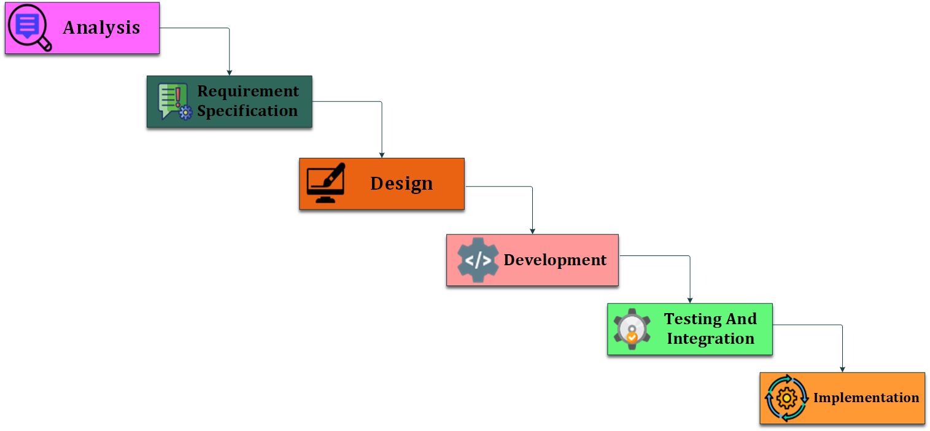

**𝐖𝐚𝐭𝐞𝐫𝐟𝐚𝐥𝐥 𝐌𝐨𝐝𝐞𝐥**

* 𝘞𝘦 𝘢𝘳𝘦 𝘶𝘴𝘪𝘯𝘨 𝘞𝘢𝘵𝘦𝘳 𝘧𝘢𝘭𝘭 𝘔𝘰𝘥𝘦𝘭 𝘣𝘦𝘤𝘢𝘶𝘴𝘦 𝘦𝘢𝘤𝘩 𝘱𝘩𝘢𝘴𝘦 𝘮𝘶𝘴𝘵 𝘣𝘦 𝘤𝘰𝘮𝘱𝘭𝘦𝘵𝘦𝘥 𝘣𝘦𝘧𝘰𝘳𝘦 𝘵𝘩𝘦 𝘯𝘦𝘹𝘵 𝘱𝘩𝘢𝘴𝘦 𝘤𝘢𝘯 𝘣𝘦𝘨𝘪𝘯 𝘢𝘯𝘥 𝘵𝘩𝘦 𝘧𝘭𝘰𝘸 𝘰𝘧 𝘸𝘢𝘵𝘦𝘳 𝘧𝘢𝘭𝘭 𝘮𝘰𝘥𝘦𝘭 𝘪𝘯 𝘢 𝘭𝘪𝘯𝘦𝘢𝘳 𝘴𝘦𝘲𝘶𝘦𝘯𝘵𝘪𝘢𝘭.
* 𝘱𝘩𝘢𝘴𝘦 𝘢𝘳𝘦 𝘱𝘳𝘰𝘤𝘦𝘴𝘴𝘦𝘥 𝘢𝘯𝘥 𝘢𝘵 𝘢 𝘵𝘪𝘮𝘦.
* 𝘤𝘢𝘯𝘯𝘰𝘵 𝘳𝘦𝘱𝘦𝘢𝘵 𝘱𝘳𝘦𝘷𝘪𝘰𝘶𝘴 𝘴𝘵𝘦𝘱
* 𝘐𝘵 𝘪𝘴 𝘵𝘦𝘳𝘮𝘦𝘥 𝘢𝘴 𝘸𝘢𝘵𝘦𝘳𝘧𝘢𝘭𝘭 𝘣𝘦𝘤𝘢𝘶𝘴𝘦 𝘵𝘩𝘦 𝘮𝘰𝘥𝘦𝘭 𝘥𝘦𝘷𝘦𝘭𝘰𝘱𝘴 𝘴𝘺𝘴𝘵𝘦𝘮𝘢𝘵𝘪𝘤𝘢𝘭𝘭𝘺 𝘧𝘳𝘰𝘮 𝘰𝘯𝘦 𝘱𝘩𝘢𝘴𝘦 𝘵𝘰 𝘢𝘯𝘰𝘵𝘩𝘦𝘳 𝘪𝘯 𝘢 𝘥𝘰𝘸𝘯𝘸𝘢𝘳𝘥 𝘧𝘢𝘴𝘩𝘪𝘰𝘯.

**CHAPTER 2**

**REQUIREMENT GATHERING AND ANALYSIS**

1. **Organization details**
   * **Name of organization:**
   * **Brief details of the organization:**
2. **Meetings**
   * **Meeting with a LIC agent:**
     + **Name of the LIC agent:**
       - Vijay Mehta
     + **Requirements of the Vijay Mehta:**
       - Collecting Customer Information , Collecting policy records , Calculating own commission . Adding a new policy , and explaining all those policies to own customer etc…
3. **Type of project**
   * Web application.
4. **Method of collecting requirements**
   * Meetings / Interview.
   * Observing the data gathered.

**CHAPTER 3**

**SYSTEM REQUIREMENT SPECIFICATION**

* 1. **Introduction**
* LIC agent is a web application that allows agents to collect their customers information and provide information about policy. And calculate own commission.
  + 1. **Purpose**
  + The purpose of this software is collect agent’s customer information.
  + Collecting policy information.
  + Finding own commission.
    1. **Scope**
       - Agent can easily store client’s information in mobile and computer.
       - Agent can any time read client information.
       - Agent can find own commission very easily.
       - And agent can also store policy information and easily explain the policy information to his client.
    2. **Operating Environment**
       - Any computer device and mobile with browser can access our software.
    3. **User Classes**
       - **Admin**
         * Only admin is use our software. Admin can insert , Update , Delete of client data.
         * Only admin is store policy records.
         * Ex. Agent is admin. Agent’s store own client data and find own commission , agent can store policy information , agent can insert , update and delete data.
  1. **System Modules**
     + **Admin**
       - Administration have all rights to perform insert / update / delete data and store information.
       - Admin can store policy information.
       - Admin can find own commission.
  2. **External Interface Requirements**
     1. **Hardware Interface Requirements**
        + <Points>
     2. **Software Interface Requirements**
        + <Points>
     3. **User Interface Requirements**
        + <Points>
     4. **Communication Requirements**
        + <Points>
  3. **Non-functional Requirements**
     1. **Performance Requirements**
* <Points>
  + 1. **Security Requirements**
       - <Points>